Print Out Source Code Program

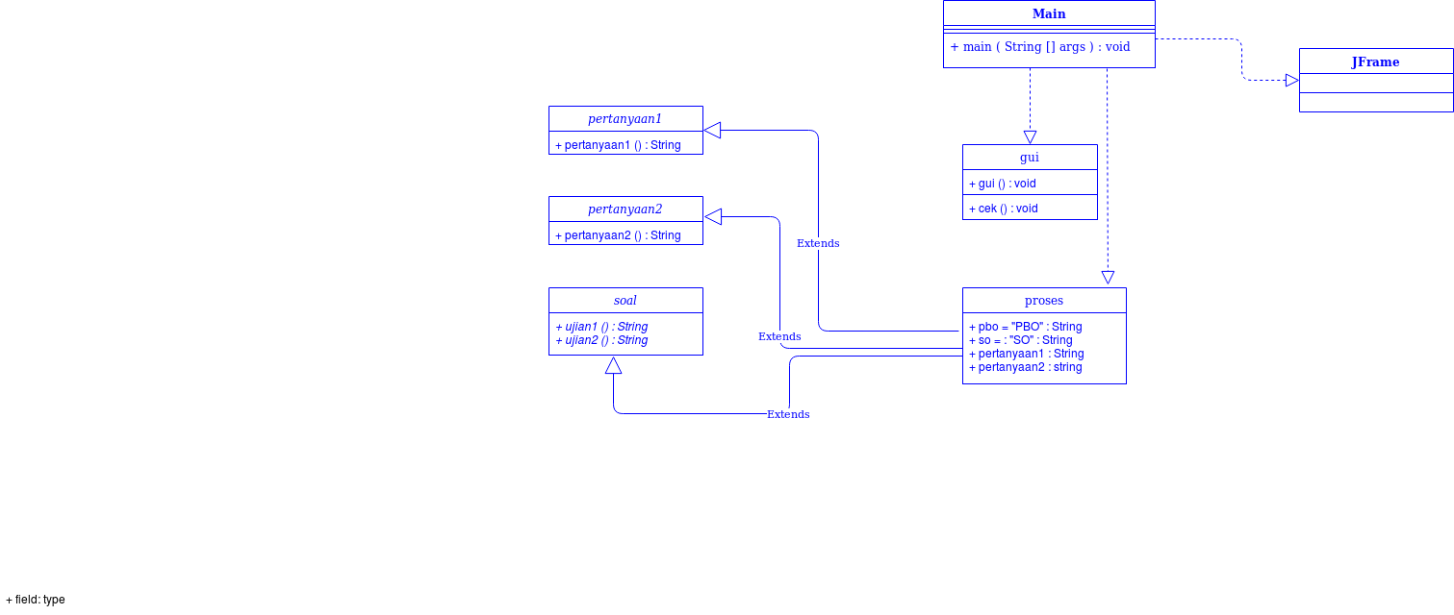

Keterangan Source Code :

------------------------------------------------------------------------------------------------------------------------------------------------------------------------------------------------------------------------------------------------------------------------------------------------------------------------------------------------------------------------------------------------------------------------------------------------------------------------------------------------------------------------------------------------------------------------------------------------------------------------------------------------------------------------------------------------------------------------------------------------------------------------------------------------------------------------------------------------------------------------------------------------------------------------------------------------------------------------------------------------------------------------------

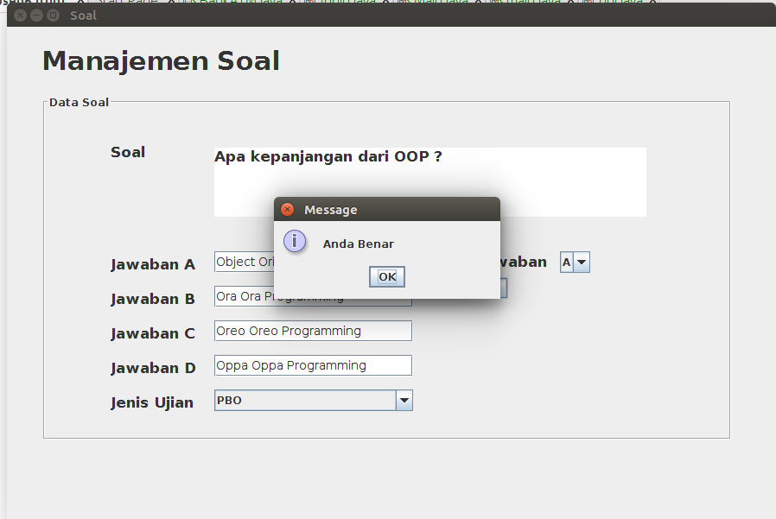

Print Out Source Code Program

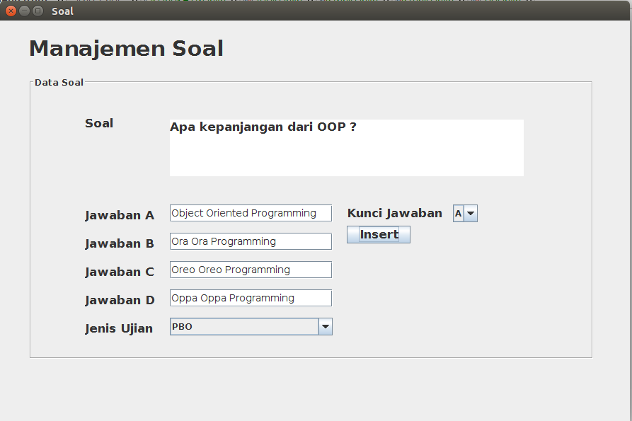

Keterangan Source Code :

-----------------------------------------------------------------------------------------------------------------------------------------------------------------------------------------------------------------------------------------------------------------------------------------------------------------------------------------------------------------------------------------------------------------------------------------------------------------------------------------------------------------------------------------------------------------------------------------------------------------------------------------------------------------------------------------------------------------------------------------------------------------------------------------------------------------------